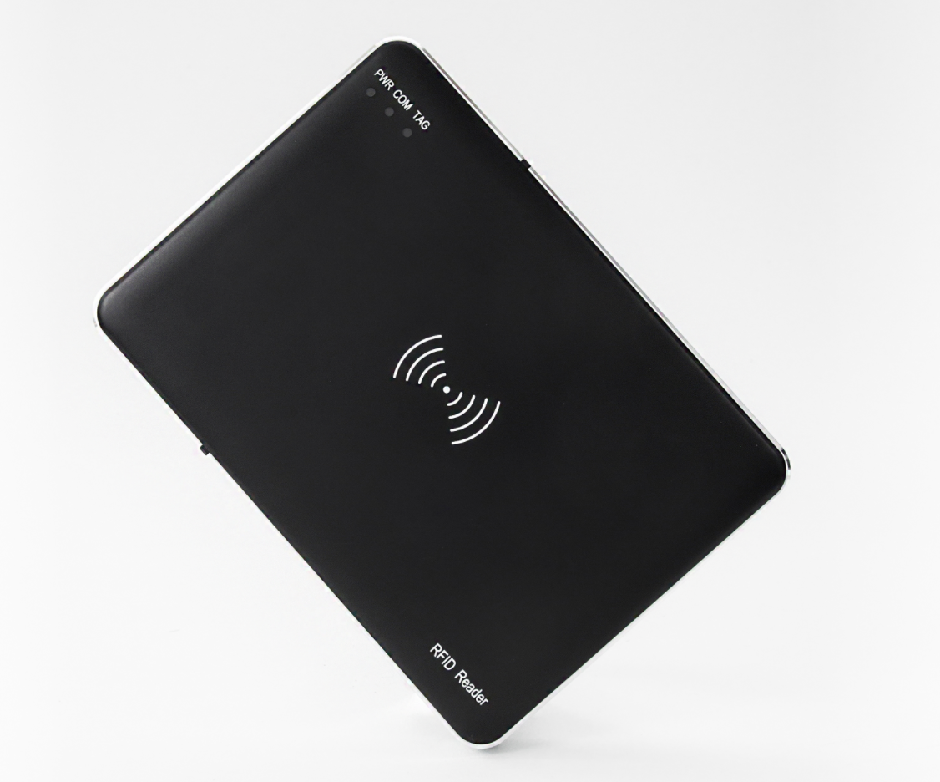

UHF rfid integrated reader
OPP-D01

- USB drive free (windows, Android)
- It has the function of audible and visual alarm
1. Product introduction:
OPP-D01 is a high-performance UHF RFID desktop integrated reader,based on the design of high-performance UHF chip, it fully supports the EPCglobal C1 Gen 2 ISO 18000-6c standard,Combined with the proprietary high-efficiency collision processing algorithm, while maintaining a high reading rate, it can realize the fast reading and writing processing of electronic tags, which can be widely used in various solutions such as personal identification, conference sign in system, access control system, anti-counterfeiting system and production process control.
2.Product parameters：
Mechanical electrical performance
Equipment size Dimension：（MM） | 170（L）*122(W)*20(H)MM（±1）
Diemension including packaging（MM） | 250（L）*230(W)*50(H)MM（±1）
Net weight：(KG) | 0.22（±0.02）
Gross weight：（KG） | 0.38（±0.02）
Antenna | Integrated Near field circularly polarized antenna
Shell | Metal frame, ABS surface shell
Performance Index
Tag / Transponder Protocols | EPCglobal C1 Gen 2 ISO 18000-6C
Frequency | 865~868MHz/902～928MHz（Can be adjusted according to different countries or regions）
Frequency modulation | FHSS or fixed-frequency, can be set by software
RF output | from 0 dBm to 26dBm* with +/-1dBm
Reading speed | >50 tags/sec
Tag Buffer Size | 330 tags @ 96 bit EPC/100@ 96 bit EPC
Tag RSSI | Supported
Interface: | Communication Interface USB drive free type-C interface
Indicator light | PWR: Red LED, Power indicator  COM: Green LED , Communication indicator  TAG： Blue LED ， Tags operation indicator
API Support | C++，C#，Java，NET
Certification | ROHS、FCC
Environment
Operating Temp | -20～+55℃
Storage Temp | -20～+85℃
Humidity | 5%～95%RH，Non-condensing

- Product images

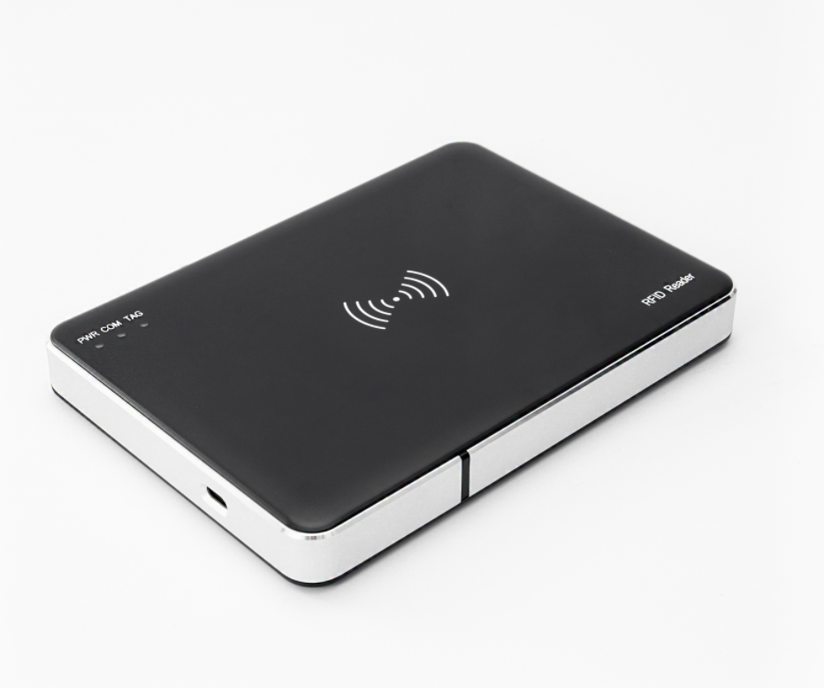

Figure 2

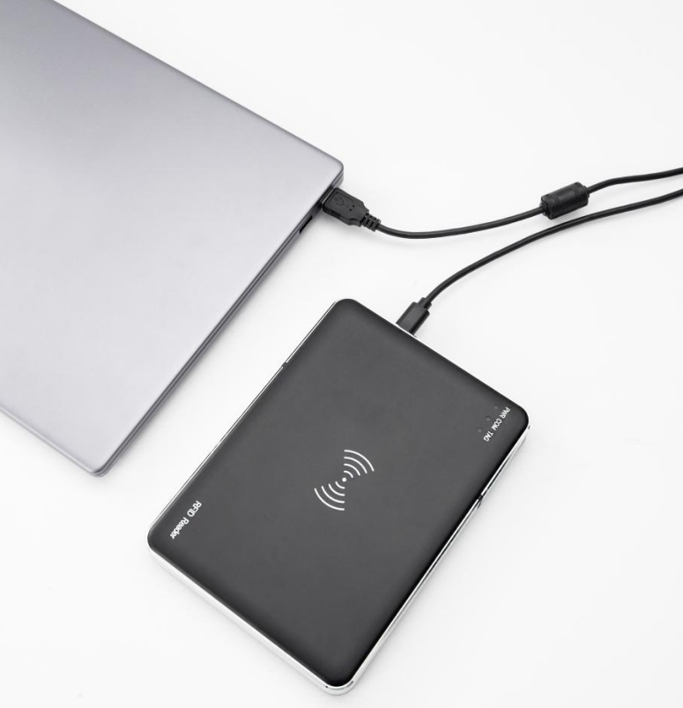

Figure3

- OPP-D01 Family Series:
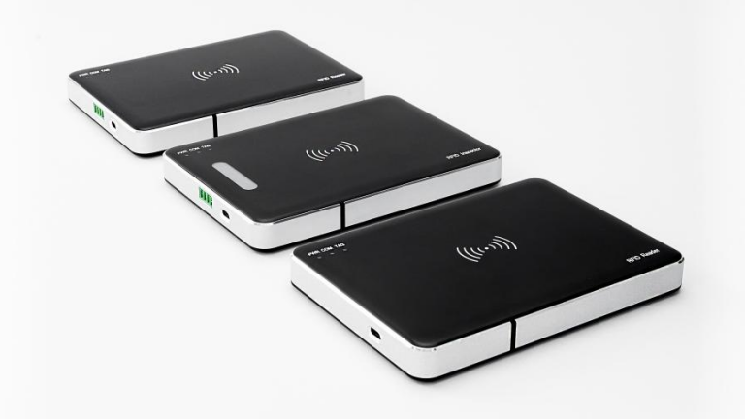

Figure 4

The above is the OPP-D01 standard version, with two additional specifications of the same size:

1. OPP-D01-K, HID mode, automatically simulates keyboard output for read tag data

2. OPP-D01-T, used for tag detection. According to the set reading threshold, after successful reading, the device's green light will light up and the buzzer will sound（See the figure below“Figure 5.
”）
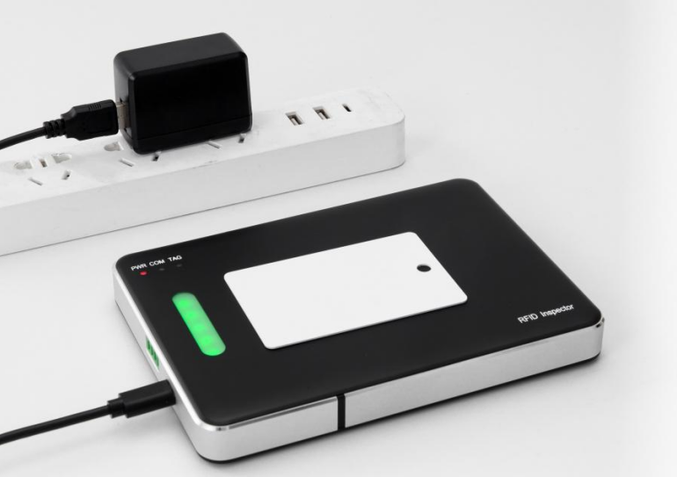

Figure 5
- Dimension drawing （MM）
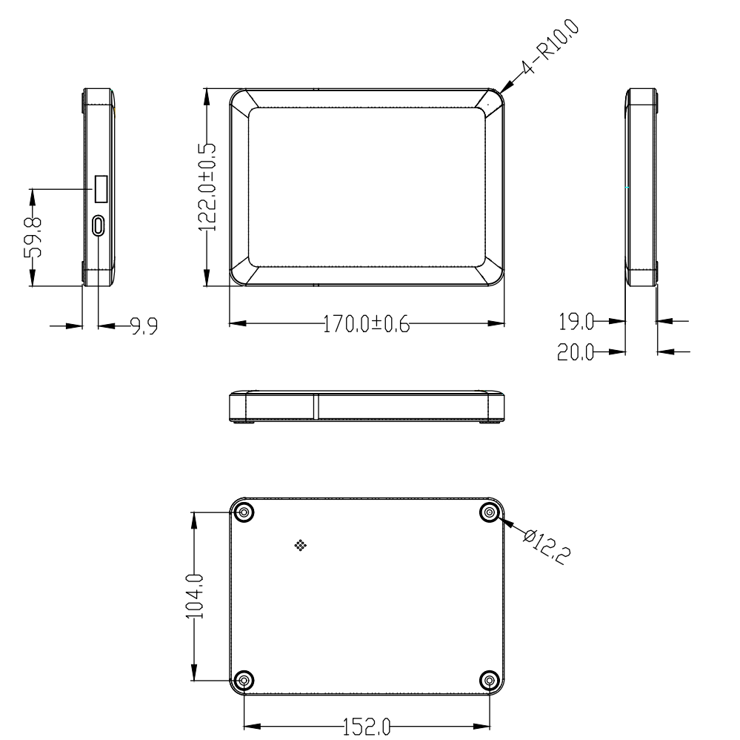

Figure 6
- Packing List

The OPP-D01 Reader * 1, USB data cable 1.5 meters * 1, Certificate of conformity * 1

