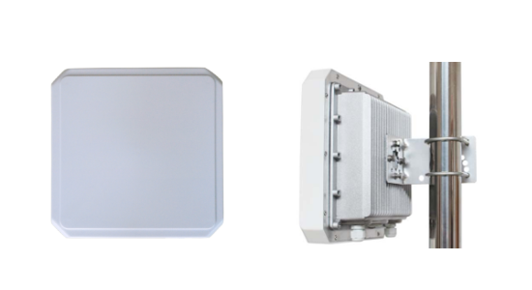 OPP-D09
1-Port Integrated UHF RFID Reader

Peak inventory speed：> 700 tags/sec

Working mode：the principal andsubordinate mode /off-line working mode/Trigger mode

In the hardware: the clock circuit is designed

1.The synopsis of the reader：
OPP-D09 is an easy to install, unobtrusive, integrated 1-port reader/antenna designed for office and commercial environments. Adopt Impinj IndyR2000 chip, with high-performance multi-tag identification algorithms.

2.Product features
Mechanical electrical performance
Dimension：（MM） | 260（L）*260（W）100（H）
Weight：（KG） | 2.1KG
Performance Index
Tag / Transponder Protocols | EPCglobal Gen 2 (ISO 18000-6C)、ISO 18000-6B (optional)
Antenna | 9DB circular polarization
Frequency | 865~868MHz/902～928MHz（Can be adjusted according to different countries or regions）
Frequency modulation | FHSS or fixed-frequency, can be set by software
RF output | from 0 dBm to 30 dBm* with +/-1dBm
Reading distance | 9dbi Antenna configuration, typical read range: 15 to 25 m (depends on tag)
Peak inventory speed | > 700 tags/sec
Tag Buffer Size | 200,000tags @ 96 bit EPC
Tag RSSI | Supported
Antenna Detector | Supported
Working mode | the principal andsubordinate mode /off-line working mode/Trigger mode
Power | With 220V AC input, the output of +12 V/3A DC power converter
input / output (GPIO) | 1 inputs, 1 output
ommunication interface | 10M/100MAdaptive Ethernet、RS232
Operating System | Linux
Environment
Operating Temp | -20～+55℃
Storage Temp | -20～+85℃
Humidity | 5%～95%RH，Non-condensing

