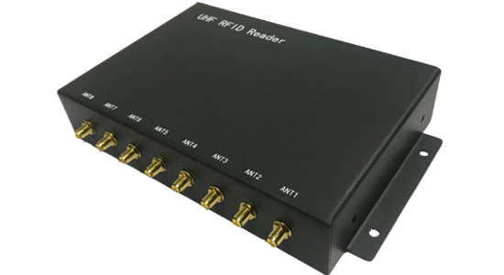
8 Channels UHF RFID Fixed Reader SRE-801

Peak inventory speed：> 700 tags/sec

Working mode：the principal andsubordinate mode /off-line working mode/Trigger mode

In the hardware: the clock circuit is designed

Interface：
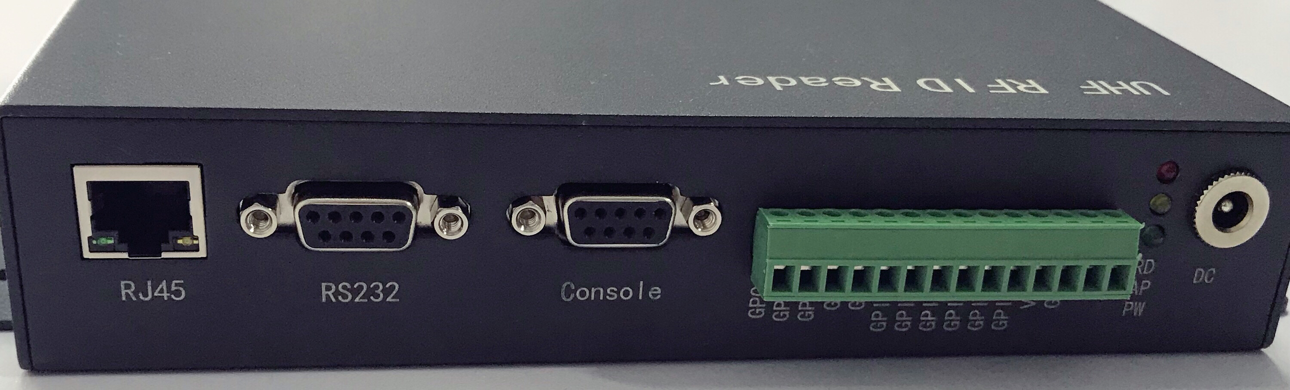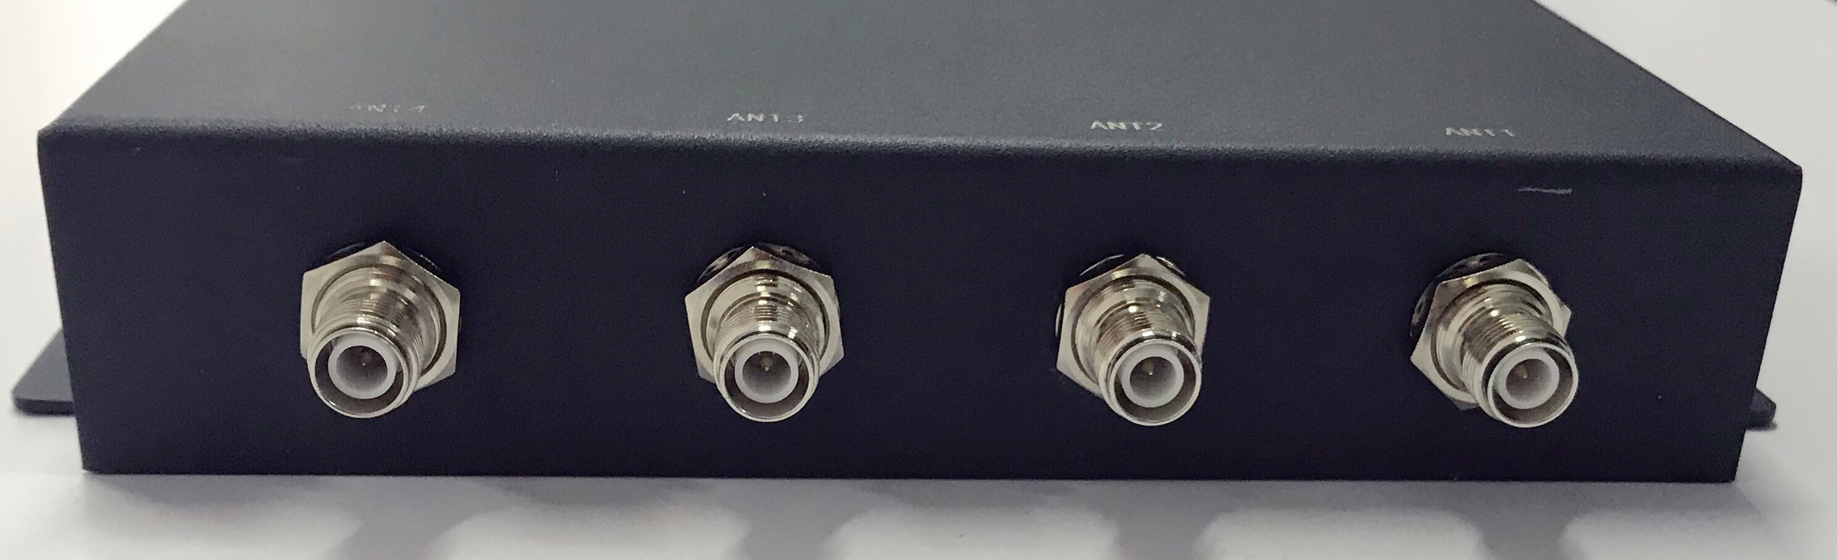

1.The synopsis of the reader：
The SRE-801 is a low profile, high-performance 8-port RFID reader designed for both indoor and outdoor applications. Adopt Impinj IndyR2000 chip, with high-performance multi-tag identification algorithms.
SRE-801 has built-in Linux operating system, which not only meets the complex customer business requirements, but also responds to various label operations independently and quickly. Multi-tag reading performance is excellent, supporting intensive reading, large capacity tag reading and writing, received signal strength detection (RSSI). It has reliable network adaptability, supports a variety of network protocols, and is easy to deploy large-scale applications.

2.Product features
Mechanical electrical performance
Dimension：（MM） | 215（L）*158（W）*38（H）
Weight：（KG） | 1.22±0.05KG（net weight）
Performance Index
Tag / Transponder Protocols | EPCglobal Gen 2 (ISO 18000-6C)、ISO 18000-6B (optional)
RF Connector | 8 SMA-K antenna connectors
Frequency | 865~868MHz/902～928MHz（Can be adjusted according to different countries or regions）
Frequency modulation | FHSS or fixed-frequency, can be set by software
RF output | from 0 dBm to 30dBm* with +/-1dBm
Reading distance | 9dbi Antenna configuration, typical read range: 15 to 25 m (depends on tag)
Peak inventory speed | > 700 tags/sec
Tag Buffer Size | 100,000 tags @ 96 bit EPC
Tag RSSI | Supported
Antenna Detector | Supported
Working mode | the principal and subordinate mode /off-line working mode/Trigger mode
Power | With 220V AC input, the output of +12 V/5A DC power converter
input / output (GPIO) | 3 inputs, 3 output
ommunication interface | 10M/100MAdaptive Ethernet、RS232
Operating System | Linux
Environment
Operating Temp | -20～+55℃
Storage Temp | -20～+85℃
Humidity | 5%～95%RH，Non-condensing

