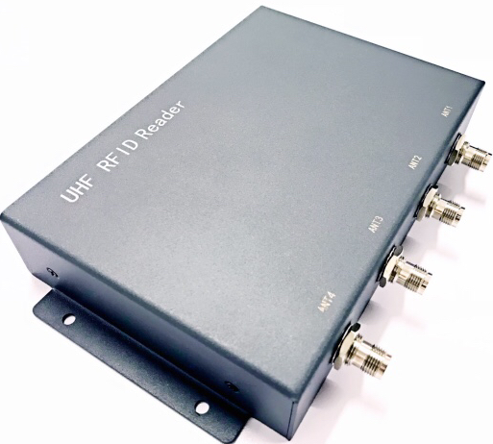
4 Channels UHF RFID Fixed Reader OPM6A

Max Tag Read Rat：:More than 750 tags/second using high-performance settings

Working mode：the principal andsubordinate mode /off-line working mode/Trigger mode

In the hardware: the clock circuit is designed

Interface：
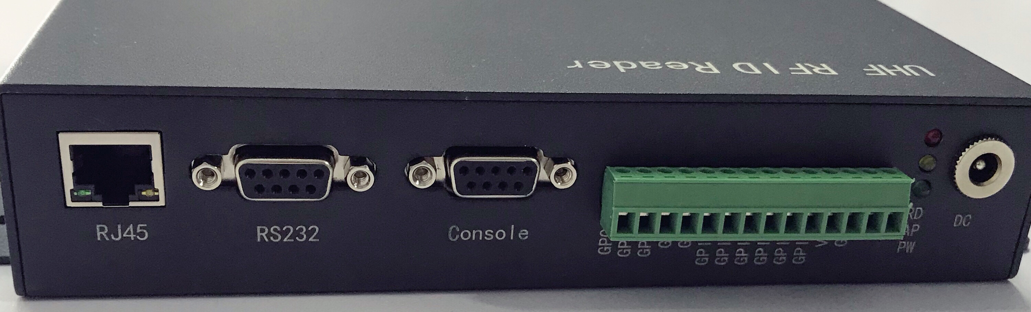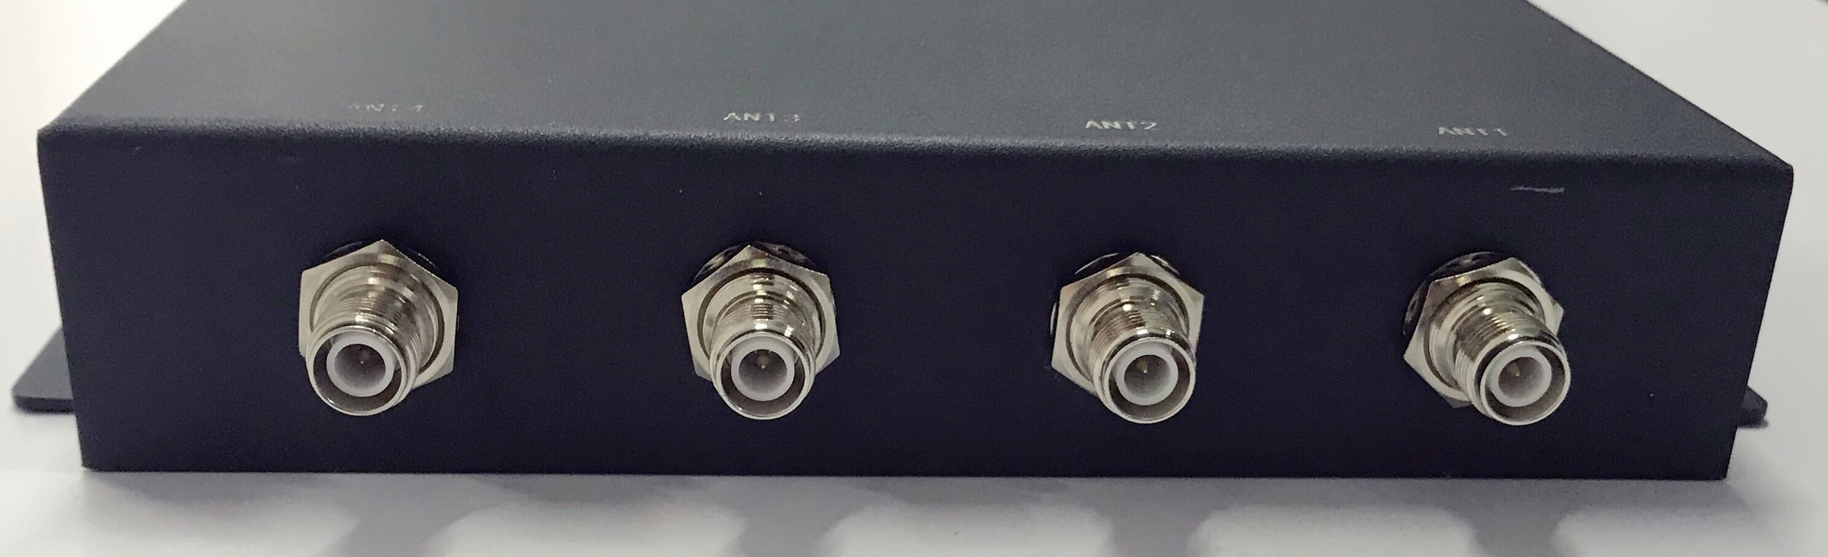

1.The synopsis of the reader：
The OPM6A is a low profile, high-performance 4-port RFID reader designed for both indoor and outdoor applications. Driven byThingMagic’spowerful Mercury6e UHF RFID reader module.
OPM6A has built-in Linux operating system, which not only meets the complex customer business requirements, but also responds to various label operations independently and quickly.

2.Product features
Mechanical electrical performance
Dimension：（MM） | 215（L）*158（W）*38（H）
Net Weight ：（KG） | 1.18±0.05KG
Gross weight：(KG) | 1.176±0.05KG
Performance Index
Tag / Transponder Protocols | EPCglobalGen2(ISO18000-6C) with DRM ISO18000-6B(optional)  IP-X(optional)
RF Connector | 4 RP-TNC antenna connectors
Frequency | Pre-configuredforthefollowingregions:  FCC 902-928MHz(Americas)  ETSI 865.6-867.6MHz(EU)  KCC 917-920.8MHz(Korea)  TRAI 865-867MHz(India)  ACMA 920-926MHz(Australia)  ‘Open’ (Customizable)865-869MHz, 902-928MHz
RF output | Separate read and write levels,command adjustable from 5dBm to31.5 dBm* (1.4W) with +/-0.5dBm accuracy above +15dBm
Reading distance | Over 30 feet(9m) with 6dBi antenna (36dBm EIRP)
Peak inventory speed | > 750 tags/sec
Tag Buffer Size | ＞100,000tags @ 96 bit EPC
Tag RSSI | Supported
Antenna Detector | Supported
Working mode | the principal and subordinate mode /off-line working mode/Trigger mode
Power | With 220V AC input, the output of +12 V/3A DC power converter
input / output (GPIO) | 3 inputs, 3 output
ommunication interface | 10M/100MAdaptive Ethernet、RS232
Operating System | Linux
Application Interface | Direct Communication:EPCglobal Low Level Reader Protocol (LLRP) v1.1  On reader API:MercuryOS CAP I  HostAPI:Java,C,.NET
Environment
Operating Temp | -20～+55℃
Storage Temp | -20～+85℃
Humidity | 5%～95%RH，Non-condensing

