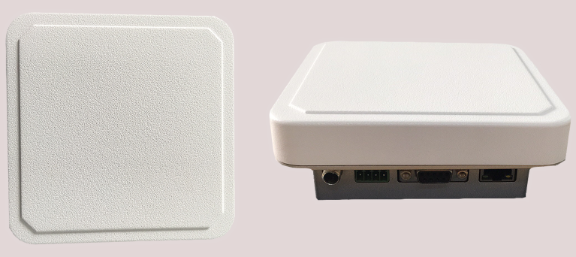

UHF rfid integrated reader
OP-D06

1.The synopsis of the reader：
The OP-D06 is a low profile, high-performance UHF rfid integrated reader.OP-D06 has built-in Linux operating system, which not only meets the complex customer business requirements, but also responds to various label operations independently and quickly. OP-D06 is based on the design of high-performance UHF chip, it fully supports the EPCglobal C1 Gen 2 ISO 18000-6c standard. Combined with the proprietary high-efficiency collision processing algorithm, while maintaining a high reading rate, it can realize the fast reading and writing processing of electronic labels, which can be widely used in various solutions such as personal identification, conference sign in system, access control system, anti-counterfeiting system and production process control.

。
2.Product features
Mechanical electrical performance
Dimension：（MM） |  | 129（L）×129（W）×49（H）
weight：（g） |  | 395±5g（Net weight）
Shell |  | the shell is made of white ABS and the bottom shell is made of silver cast iron
Antenna |  | integrated 5.5 dBiC antenna
Performance Index
Tag / Transponder Protocols |  | EPCglobal C1 Gen 2 ISO 18000-6C
Frequency |  | 865~868MHz/902～928MHz（Can be adjusted according to different countries or regions）
RF output |  | from 0 dBm to 26dBm* with +/-1dBm
Reading distance |  | ＞2m（eg.9662，depends on tag）
Peak inventory speed |  | >50 tags/second
Tag RSSI |  | Supported
Antenna Detector |  | Supported
Working mode |  | the principal and subordinate mode /off-line working mode/Trigger mode
Power |  | With 220V AC input, the output of +12 V/5A DC power converter
input / output (GPIO) |  | 1input, 1 output
communication interface |  | 10M/100MAdaptive Ethernet、RS232
Operating System |  | Linux
Environment
Operating Temp | -20～+55℃
Storage Temp | -20～+85℃
Humidity | 5%～95%RH，Non-condensing

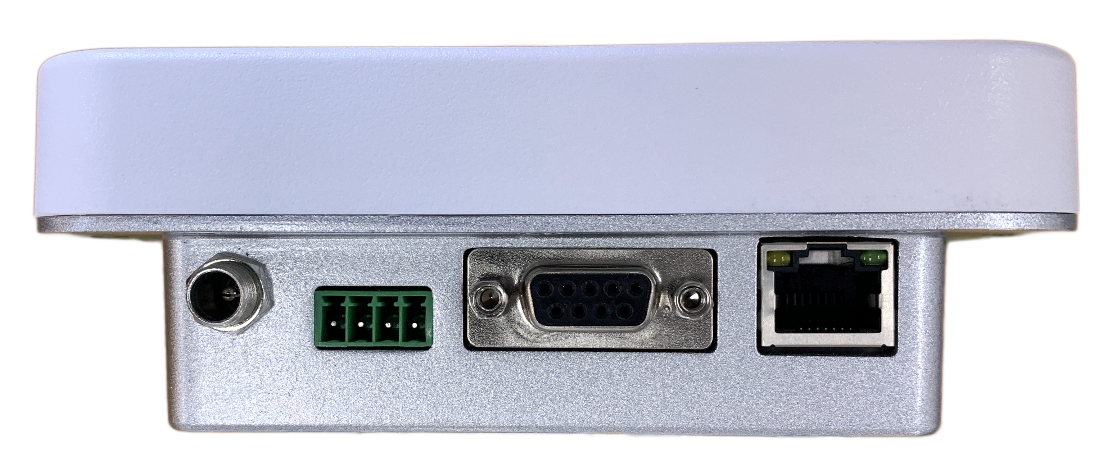
3.Interface diagram：

DC GPIO RS232 RJ45

